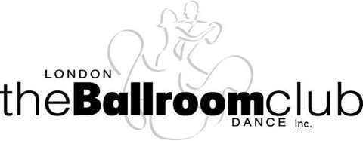
Page 1

Membership Form

2025-2026

 | Last Name: |  | First Name:
 | Address:
 | City: |  | Postal Code:
 | Phone No: |  | Email Address:
PARTNER
 | Last Name: |  | First Name:
 |  | Address as above or
 | Address:
 | City: |  | Postal Code:
 | Phone No: |  | Email Address:

Membership is $35 per person

Funds are non-refundable and payable in advance to Treasurer@lbdc.ca
via etransfer.
Membership forms must be returned signed (electronic preferred) and all fees paid prior to lessons.
If you have any questions or wish to pay by cheque, please contact us at the email below.
Please email this form to londonballroomdanceclub@gmail.com

Page 2

Release and Waiver of rights in the event of loss or injury

By either registering for or participating in any program or event organized or hosted by the London Ballroom Dance Club Inc. (“LBDC”) each of the undersigned, on his or her own behalf and also on behalf of his or her heirs, executors, administrators, assignees or agents, acknowledges that participating in the programs and events offered by the LBDC (such as dance lessons, club practices, trips, or club dances) can be hazardous and that he or she participates in such programs and events entirely at his or her own risk. Each of the undersigned, again on his own behalf and on behalf of the third parties mentioned above, hereby releases, indemnifies and holds harmless
A the LBDC, its officers, dance instructors, members, employees, agents and contractors,
B any volunteers or other individuals involved in the organization of, or participating in, any LBDC program or event
from and in respect of all actions or causes of actions, claims, demands and any other rights which the undersigned may (but for this waiver) have had against any of the persons described at A or B above because of any injury or loss suffered by the undersigned as a result of or in any way connected with participating in any LBDC program or event. This waiver extends even to injuries or losses suffered by the undersigned and caused by carelessness on the part of any of the persons described in A or B above.

Photo and Video consent

I acknowledge that the LBDC may take my picture or video at LBDC events, such as dance lessons, club practices or club dances. I acknowledge and agree that the LBDC may publish or use the image or video for any LBDC purpose by any means whatsoever including, but not limited to electronic or digital means. I acknowledge that the LBDC may not be able to control the distribution or use of the image or video by other than LBDC representatives. I agree that this consent and release is given in perpetuity and for no credit, acknowledgment or financial recompense now or in the future.

Privacy content

I agree to the collection of this personal information for the exclusive use of the LBDC.

Electronic messages

I consent to receive electronic messages from the LBDC, including newsletters, information, and other notifications about the LBDC.

Inappropriate Behavior

I understand inappropriate behavior will not be tolerated and can lead to my removal from the club.

I acknowledge having read the above statements & I agree to such statements.

Print Name ______________________________ Signature __________________________________

Print Name ______________________________ Signature __________________________________

